Ex:No: 13

Date:

**DCL COMMANADS**

**Aim:**

To learn how to use various DCL commands GRANT and REVOKE SQL

commands

1) Grants to the username are :

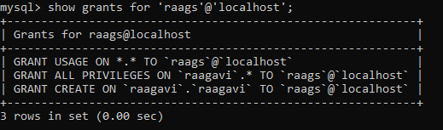

2)After revoking the permissions:

